7/25/2024
Parish Bulletins - Board member project? Policies reviewed: -Board Confidentiality Agreement -Conflict of Interest Policy -Annual Board Evaluation Policy Draft
Next month’s policies to review (cut link for address line) —WhistleBlower Policy https://docs.google.com/document/d/1GIoPkoCFNQYIa_C2M3S9MoY3uPR80IuX/edit#heading=h.gjdgxs —FISCAL, SECURITY MANAGEMENT POLICIES AND PROCEDURES https://docs.google.com/document/d/1v3STvjoh2YImc6iUQnMWwldj88Jj9cTIsssZdmGhm9o/edit
Board minutes - June https://docs.google.com/document/d/1HAf6K0Q0ohRitLuyRO-o-5BJL-uv0F8h/edit
Ed Report:
—-Ruth’s Update 7/24/2024 —-Our Place building struggles —-Store sales very low see contingency plan
Contingency Plan/Budget
—-Not to hire lead store manager keep the assistance mgr —-Opening hours back to 9:00-7:00, donations accepted Tuesday - Saturday. Will discuss further at Wednesday meeting —Work with marketing staff for store daily/weekly updates

Jul 17, 2024
Leases have been finalized by Commerce for Ruth’s Place
- We have started PR for Ruth’s Place: 'Let's do it right': New collaborative to open women's shelter Ruth's Place
https://helenair.com/news/local/plans-for-womens-shelter-restarted-after-non-profit-collaboration-good-samaritan-ministries-theresa-ortega-renee-bauer/article_4451c176-406a-11ef-a02e-63182d51036a.html#tracking-source=home-top-story
- Today, HTV came by to interview with Renee FP and I to be on the 5 and 5:00 news tonight
- Store numbers continue to be low. I am hoping with a new store manager we will see change
- Our new Development/PR staff is moving quickly for FB, WEB, Letters and working on the Saint Francis Dinner
- HR has hired a replacement Street Outreach staff. In addition, we were notified by the county that we received the Community Diversion Grant (CDG) that will cover street outreach for two staff. Yay!!!
- HR will be posting for a store manager - changes
- Our Place has been very busy in the last month! We are seeing an increase of mental health challenges and drug use in addition we are seeing clients with seizures, diabetes and other medical issues.
- Assistance is doing well while reorganizing the intake organization creating a cleaner and more streamlined assistance meeting.

July 10,2024
Talking with the IR tomorrow to give initial information on Ruth’s Place
Leases have been approved by Commerce
Ruth's Place has received additional monies bringing our new total up to $615.000 +
Store has been very slow and number are not looking good
This past week I’ve been working mostly on Ruth’s Place
Not much else. .3

July 7/3/2024
Board job descriptions have not been updated in quite some time; the last board wanted them simple. We need to have all sign in July. Job descriptions are also a policy, we’ll need to review unless you all feel comfortable to view online and feel they need minimal changes?
https://docs.google.com/document/d/1JDgez3Nz8m-Fw16arUVgZKO5IsvJONsUAKw5CnWIDPs/edit
Check out the Lumen Christ nominees
https://www.catholicextension.org/what-we-do/lumen-christi-award/2024-2025-lumen-christi-award-nominees/
Brianna and I worked on the budget today in hopes of getting it to you by the end of the week, if not sooner
It was a pretty quiet week all the way around.

Jun 26, 2024
Board Meeting Calendar
https://www.goodsamhelena.org/wp-content/uploads/2024/06/Board-Mtg-Schedule-24-25.docx-1.pdf also on board portal search Finance & Board Meeting Schedule FY 24/25
Our Place May monthly report:
https://docs.google.com/document/d/1Hp0f91hPRvLG0F7J6mDnB6JYFT01gkAJ/edit
6/27/2026 Adhttps://docs.google.com/document/d/1HAf6K0Q0ohRitLuyRO-o-5BJL-uv0F8h/edit Ad hoc meeting notes
Admin:
Grants- Lowe’s Hometown we did not receive the full amount asked for, however we did get a $2000 gift card for Lowes to put towards the reception office. In total we have $6000.00. I and John will meet up on how to provide more confidentiality with the total amount we have.
Made an offer to a woman for grant writing, PR and Marketing
Programs running smoothly
Dock staff are working very hard to make up for lost staff. Tuesday, Two gentlemen from the Hannon House came over to volunteer. One will be applying.
Ruth’s paperwork is moving quickly. Next steps are to get completed blueprints from the architect, city zoning meetings then start building.
Buffalo Export LLC Items Purchased from Vendors For the Period From Jul 1, 2023 to Jun 30, 2024 Filter Criteria includes: 1) Vendor IDs from GOODSAMAR to GOODSAMAR. Report order is by Vendor ID, Item ID. Report is printed in Detail Format
Item Description Qty Stocking U/M Amount BELTS PURSES 1855 185.50 BOOKS 14219.00 142.19 BRIC-A-BRAC 996.00 49.80 BASEBALL CAPS 356.00 178.00 HARD TOYS 2337.00 233.70 MIXED RAGS 141355.00 14,135.50 OTHER SALES 1.00 70.50 SHOES 5910.00 1,773.00 SINGLE/REJECT SHOES 617.00 6.17 SPORTING SPORTING GOODS 1.00 2.00 STUFFED ANIMALS 1314.00 131.40 SUITCASES 1476.00 29.52
Total lbs: 170437.00 Total amount paid to GSM 16,937.28
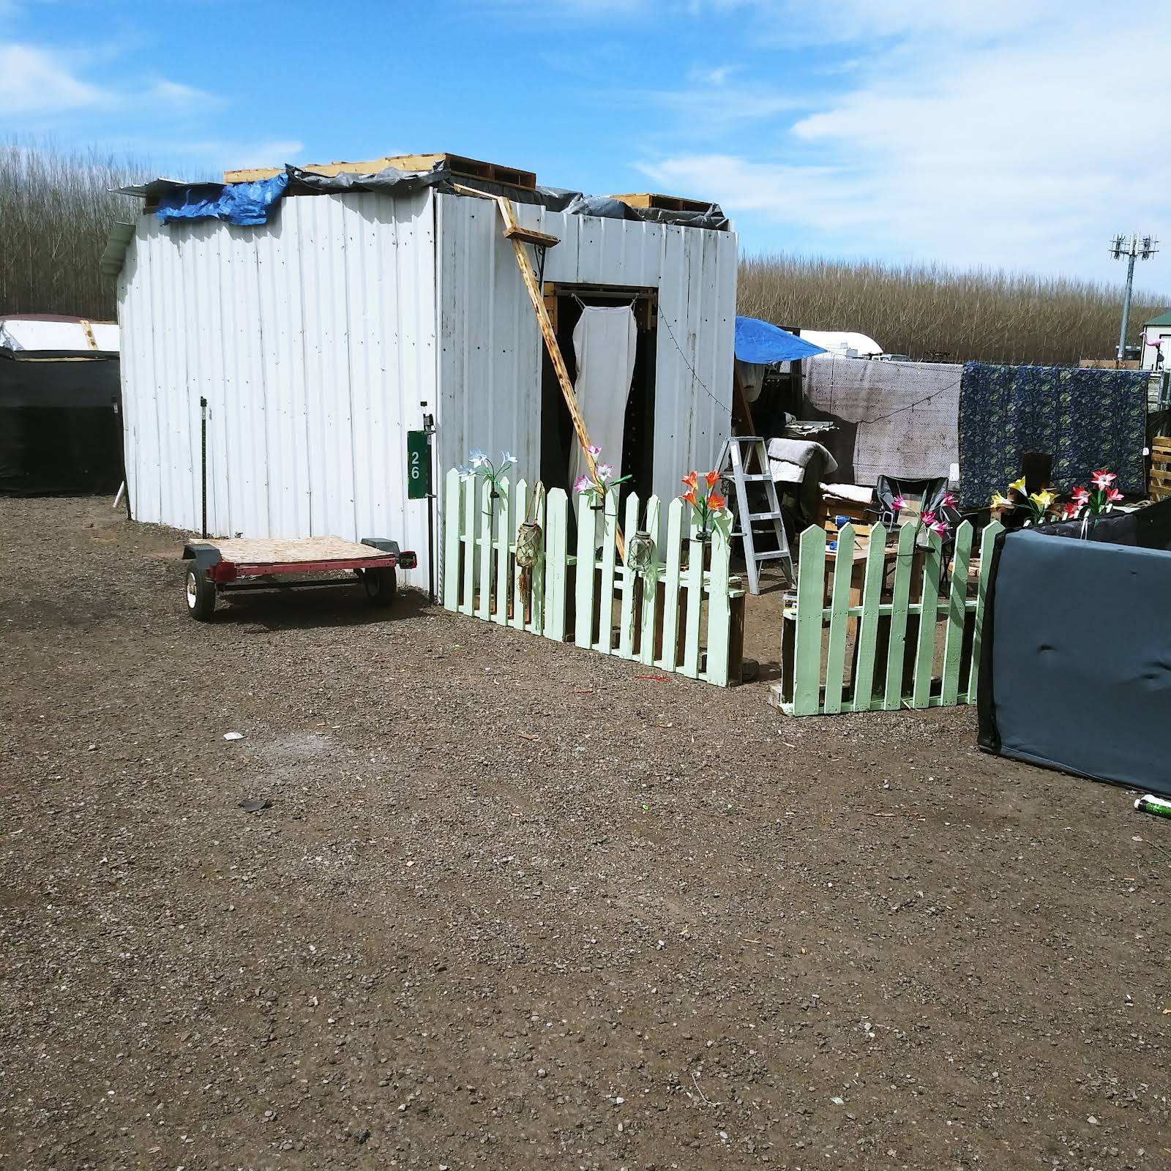
Not all homes are created equal!

"On this Juneteenth, we join the community in celebrating the end of slavery in the United States, marking a significant moment in our nation's history. As an organization rooted in Catholic values and dedicated to supporting all people, we honor this day as a reminder of the ongoing journey towards equality and justice for everyone. Let us reflect on the importance of freedom, unity, and the work that still needs to be done to ensure that all members of our community are treated with dignity and respect. Together, we can build a more just and loving world."
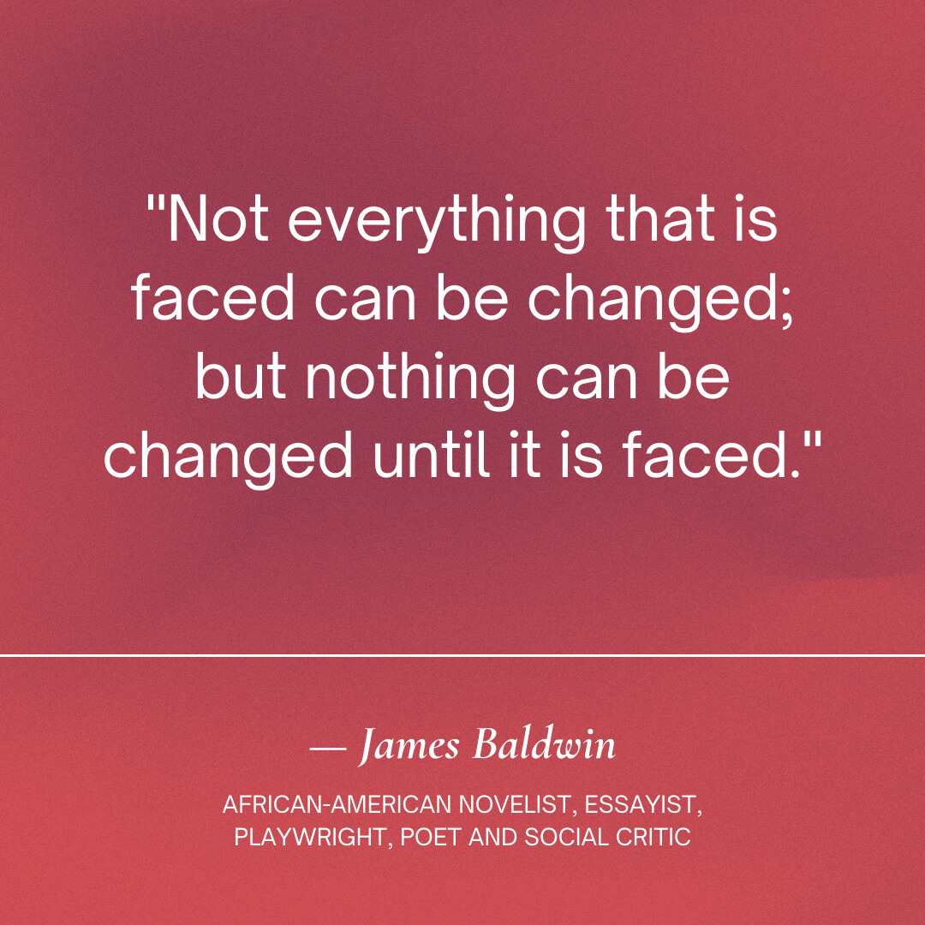
- $1200 of curriculum purchased by Lewis and Clark County for Our Place Drop-in Center
- Grants: Foundation for the Diocese of Helena resubmit report and sent new grants
- Let’s review at the meeting, or respond by email if board members would be willing to make a donation, individually, as the match grant for the State Fund-Ace grant for a floor buffer. We need a new one that will actually clean. The match is $2000.00 which would be $250 for our current board members. At this point we do not have funds to provide the match.
- John Mundinger: Would the board rather wait until after summer to set up a Strategic review/ update after summer?
- Fiscal the 25th, and board meeting the 26th next week. Brianna is at a family reunion returning on Monday docs will be out Monday. Does the board still plan on meeting the 26th to review the first two policies I sent out? Conflict of Interest Policy and Annual Statement https://docs.google.com/document/d/1gGMzkQ0PsXbRjafjXBeCIgcqndSHiRs_nKiBoBKR Board Evaluation Policy Board Evaluation Policy Draft 8-1-2018-Links in May 15th report
- Ruth’s Place lease has been sent to the Diocese attorney for final review. We do need to talk about the board’s final decision/approval. At a previous meeting it was brought up that the board wanted to make a final decision once all was done and in place. Please let me know if you have any questions about this decision. Once the leases are back and signed by those needed, and the board gives final blessing we will go public with PR on the project.
- HR: staying on top of all things HR
- Store: Sales are not what we would like to see for multiple reasons; economy and retail, shortage of staff from time to time, I do think rebuilding after such a long closure, and what I have experienced in an election year. We always see highs and lows with the weather. In my opinion, we need to look at a new norm which I hope to show in the draft budget.
- Grant writer/social media: We are so sorry to see Kat go after a short time but definitely amazing work which has kicked the standard up for the position. We have three applicants for the position. Hope to fill it within two weeks.
- Fiscal: An assistant has been hired that has taken a chunk off of Brianna as well as a few catch up projects. We hope to let our Colorado staff go once the assistance is fully trained.
- Receptionist: Huge improvement in her skills. She is taking on more tasks that have helped me tremendously.
- Assistance: I am very pleased with her work, collaboration internally and externally
- Our Place DiC: Monthly board meeting-Our Place Monthly Report Template.docx Would you like to see these reports monthly?
- We have finally received our new 9-passengers ADA Van-We are working on all documents needed and GSM - How is my driving stickers.
- My husband has accepted a position in Minnesota as Vice President of Advancement . I’ll need to drive with him leaving Friday morning and returning Tuesday, pending flights. I will be working while traveling.
- Lastly, Personally and professionally I am doing much better kicking back into action with a good attitude. This also might have to do with an amazing team who are moving programs forward and much more. I have been able to delegate with action

June 12, 2024
Administration
- Grants/Other:
  - GSM did not receive the Montana Health Care Foundation . We had applied to work with Pureview on billing for Street Outreach
  - GSM Store is in need of a new store buffer. Kat is writing a grant to State Fund The grant will require a 50% match. We are looking for a partner for the match which will be roughly $2000. Any ideas of who we might ask? Might board members consider providing the match, or getting close to the $2000? If eight board members donated $250 that would be $2,000. Presto! our match is met.
  - Montana HealthCare Foundation(MHCF): GSM wrote to partner with Pureview to bill medicaid for Street Outreach. Unfortunately, we did not receive the grant. I spoke with the grant person for evaluation of our grant. The grant was well written and scored well. The issue was that there were multiple grant requests from other non-profits, who were also not able to bill, asking to collaborate with a licensed mental health/medical facility. The outcome: MHCF is pulling all non-profits together who requested billing collaboration as a COHORT to create ways to bill and train. More information to come as it is received.
  - HR: Working on staff incentives, most recently a dinner certificate for perfect timesheets.. “Right on Tills and others in the making. There has been a mass improvement. Now HR all perfect timesheet names are put into a hat.
  - Self evaluations have been passed out to all staff that have been with GSM over 6-months.
- Board Awareness: Please read the attached article, also available as a download or to listen, as it has to do with people who are homeless without a safe place to be. Johnson V. Grants Pass-The most important Supreme Court case about stopping de-criminalizing homelessness in 40+ years.
Johnson v. Grants Pass is a court case originally filed in 2018 that determined it is cruel and unusual punishment to arrest or ticket people for sleeping outside when they have no other safe place to go. https://johnsonvgrantspass.com/
CD: I ran into Jack VB who let me know he had spoken to Brad so I thought I would add what information on types of CD and percentages for CDs: CD: 3 or 4 mo 4.15%, PB Savings: 2.54% or Sweep Account 2.54%
- Store: July 1st the store will stay open until 7:00. Prior to closing at 6:00, staying open until 7:00 we saw an annual revenue of $50.000.
- Store will no longer be closed from 1:00-2:00. We are fully staffed on the dock and we are working to change schedules.
- Lastly, Kat, our new grant writer/social media manager has submitted her resignation. The resignation had nothing to do with salary, our team or GSM overall. She was very happy, however she was recruited by Helena Area Foundation. The position is being put up as of this writing.

Jun 5, 2024

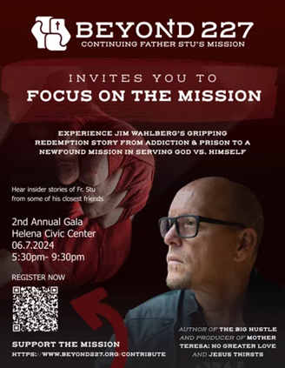

Friday night, 5:30 - Helena Civic Center I would guess business casual?
- Our signer sheet with Valley Bank has been updated to include signers: Theresa Ortega, Travis Grotbo, Russell Eleman, John Umstead. Thank you all for your quick response with Valley Bank.
- A Community Development Grant has been submitted to the county for Street Outreach to build and enhance our existing SO team
- GSM has been written into what is called the PATH grant as a team/community support for Housing Navigator.
- Fiscal and admin staff will start working on the budget this week
- Our new fiscal assistant has been hired and in training since last week
- Store: Running well with limited staff but new staff and cashiers are being hired. The store lead has been posted
- 2024-2025 board meeting list: https://docs.google.com/document/d/1_RNgyuqFV_BNw00ED84rgD9PHe7tMpkW/edit
- May minutes: https://docs.goo;gle.com/document/d/11lsnbu9ly98BnCNhGDdIv1VKznU11sHWUFXxZP2QFxM/edit
- May agenda: Review of board policies: Conflict of Interest Policy and Annual Statement https://docs.google.com/document/d/1gGMzkQ0PsXbRjafjXyBeCIgcqndSHiRs_nKiBoBKR Board Evaluation Policy
- Board Evaluation Policy Draft 8-1-2018
Please correct me if I am wrong but were we going to use opposite board meetings for ad hoc needs such as reviewing the policies?
Insurance coverages:
- Leverage Page for insurance. https://doc-0s-cc-apps-viewer.googleusercontent.com/viewer/secure/pdf/1hvlmp5223v51v3o57unvl27f8cuk5lr/82io0b96tfimi7g0udkmqubgd7c16ckh/1717522275000/gmail/07866535862564631436/ACFrOgA_CDYvNGB2IvetupydNsspHEcGd1_4wzahXh0VSafkuRrvYuCz2E3xRDPuE3JXppISnHT9qfYsTFzhMLuSRdbB1SUqOfPfeJOaiEQjLBrPJ6LbNa6kxlqNJVRZw18q_DhICOCzCwxykcdp?print=true&nonce=md43c6uah3nsi&user=07866535862564631436&hash=etskkll9of17eg927b3vuunvkra15nsp. When we start a new grant/contract Catholic Mutual is called for a new Certificate of Coverage specifically for the grant/contract and lists the name i.e. State of Montana Or Lewis and Clark County.
- Board project
- FYI-Our Place has increased coverage to $3,000,000, Our Place professional services coverage is at $2.250,000 for the state of Montana. Ruth’s Place- We are waiting for the lease to be drafted, then to submit to Catholic Mutual, for review and send a certificate of coverage to begin the start date.
- Our Place - doing well, we have moved a staff from OP to the store for a better fit and availability.
- Conflict of Interest Policy: Board Confidentiality policy 11/2022 Please review and sign for the new fiscal year 2025.
- Store staff are working hard making sure the sales floor is full.
- Assistance office has been busy included the update of assistance guidelines
- HR development of a training plan:
  - NEW HIRE TRAINING
  - - Employee Handbook
  - - New Hire paperwork
  - - VIRTUS (Safe Environment)
  - - The FISH Philosophy
  - - ON-SITE ORIENTATION TRAINING- OUR PLACE
  - - See attached
  - ADDITIONAL TRAININGS:
  - - HIPAA
  - - BLOOD BORNE PATHOGENS
  - - SELF DIRECTED TEAMS
  - - CASE NOTES AND DOCUMENTATION
  - - INCIDENT REPORTING
  - - ADULTS WITH DISABILITIES ACT TRAINING
  - - POSITIVE BEHAVIOR SUPPORT
  - - POSITIVE PROFESSIONAL COMMUNICATION (7 HABITS OF HIGHLY EFFECTIVE
  - PEOPLE)
  - - CATHOLIC MUTUAL DRIVING COURSE
  - - LIFTING AND TRANSFERRING
  - - PEOPLE FIRST TRAINING
  - - PERSONALITY BASIS TEST AND ACCOMPANYING TRAINING (SUBJECT TO
  - FUNDING)
  - General GSM Organizational Overview Training and;
  - Time Management training
- Development:
Kat will be attending our July meeting to give her plans Grant Submitted for Street Outreach Community Development Grant Multiple posts have gone out to include printed informational
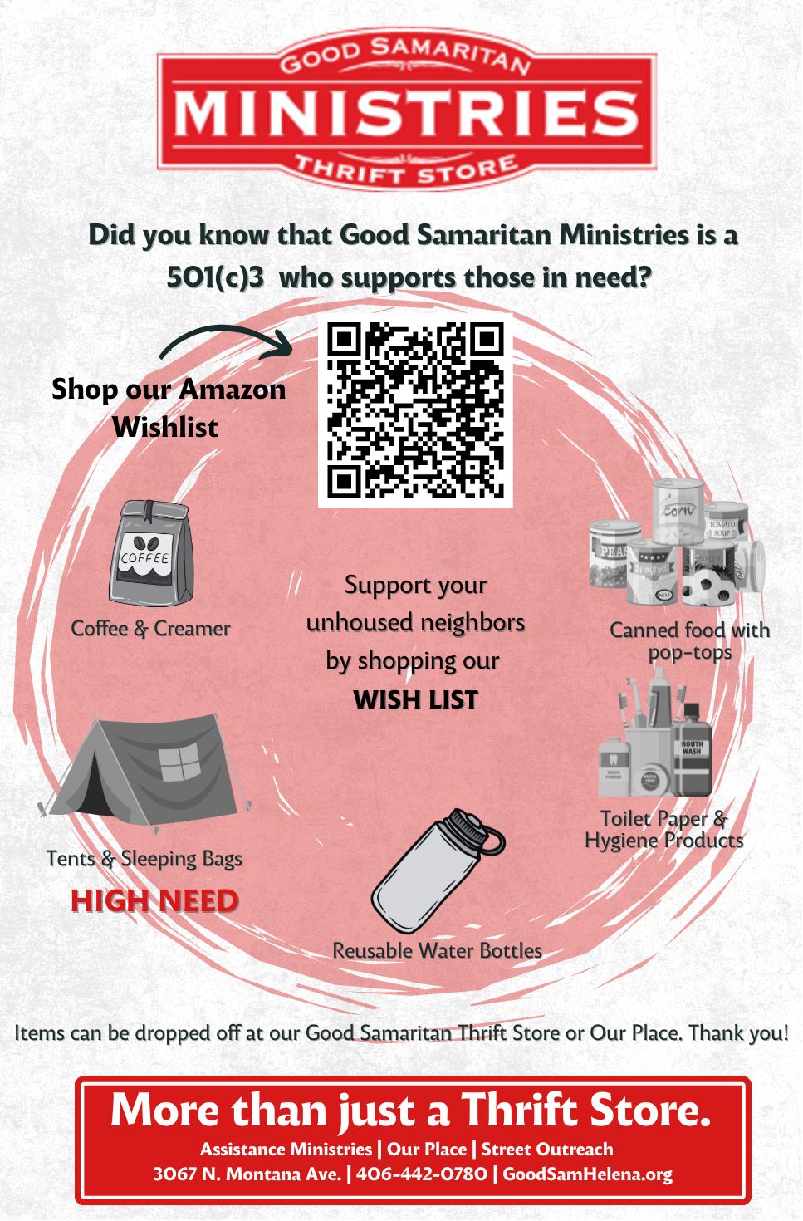

May 22, 2024
FYI, I will be out of the office from the 23rd to the 29th or 30th visiting my grandkids in Idaho. I will be working and answering emails between hockey, kid hikes, helping to move and outings.Great job Samatha, our HR coordinator! .
Hooray: Congrats on becoming a Responsive Employer from Indeed! An Employer Response Badge is an icon that shows up on jobs in Indeed search results. It lets the job seeker know that you as an employer are highly engaged and committed to responding to applications from job seekers. It is a valuable insight for job seekers as they decide which jobs to apply to.
The 2016 Strategic plan done by John Mondunger is now on the board portal under Wednesday’s reports. This was the best SP we have ever had.
Brianna and I would like to discuss the possibility of the board and finance meeting being on the same day instead of splitting the days?
Hooray: We finally received our contract for the ADA 6-passenger Van. The Van was written for Our Place and Street Outreach.
“Social justice is an ideal condition in which all members of society have the same basic rights, protection, opportunities, obligations, and social benefits.” - Michael B. Friedman, LMSW
GSM is splitting a table with Catholic Radio and will have four seats. I will be attending and wanted to offer seats to our board members. It would be nice to have a show of board members to support GSM, Catholic Radio, Fr. Bart Tolleson and Fr. Stu. Please let me know if you would like a ticket, GSM will be purchasing the tickets. More information: https://www.beyhttps://www.beyond227.org/ond227.org (cut and paste). Please let me know ASAP for Rose Casey to plan.
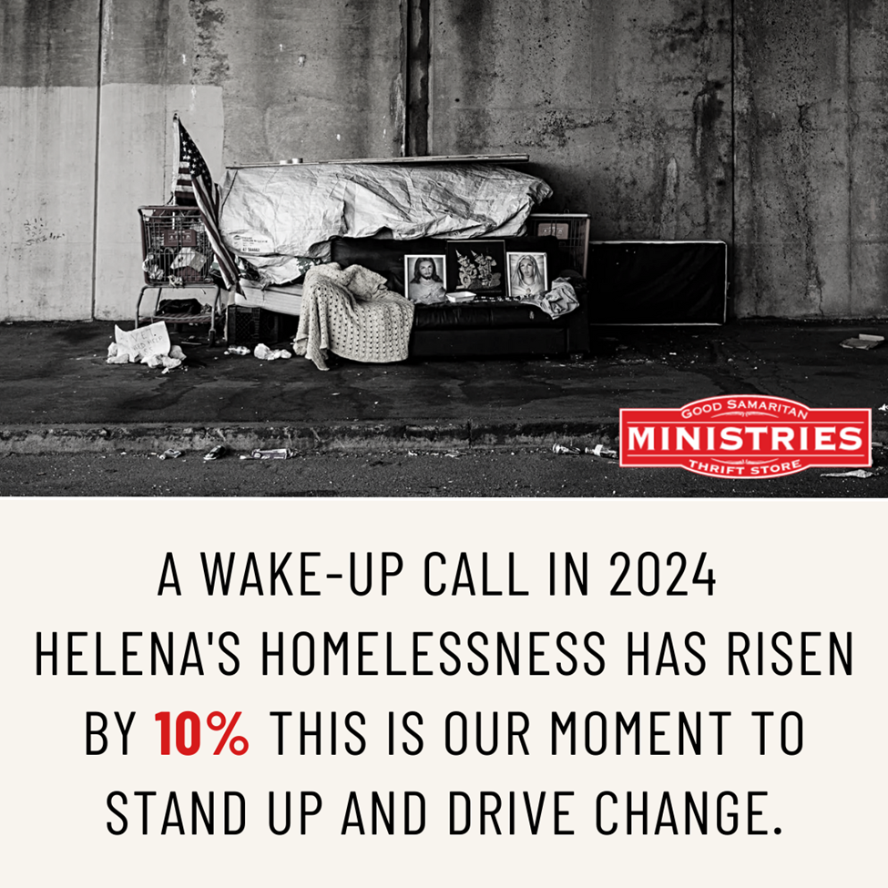
So happy to receive a sleeping bag.
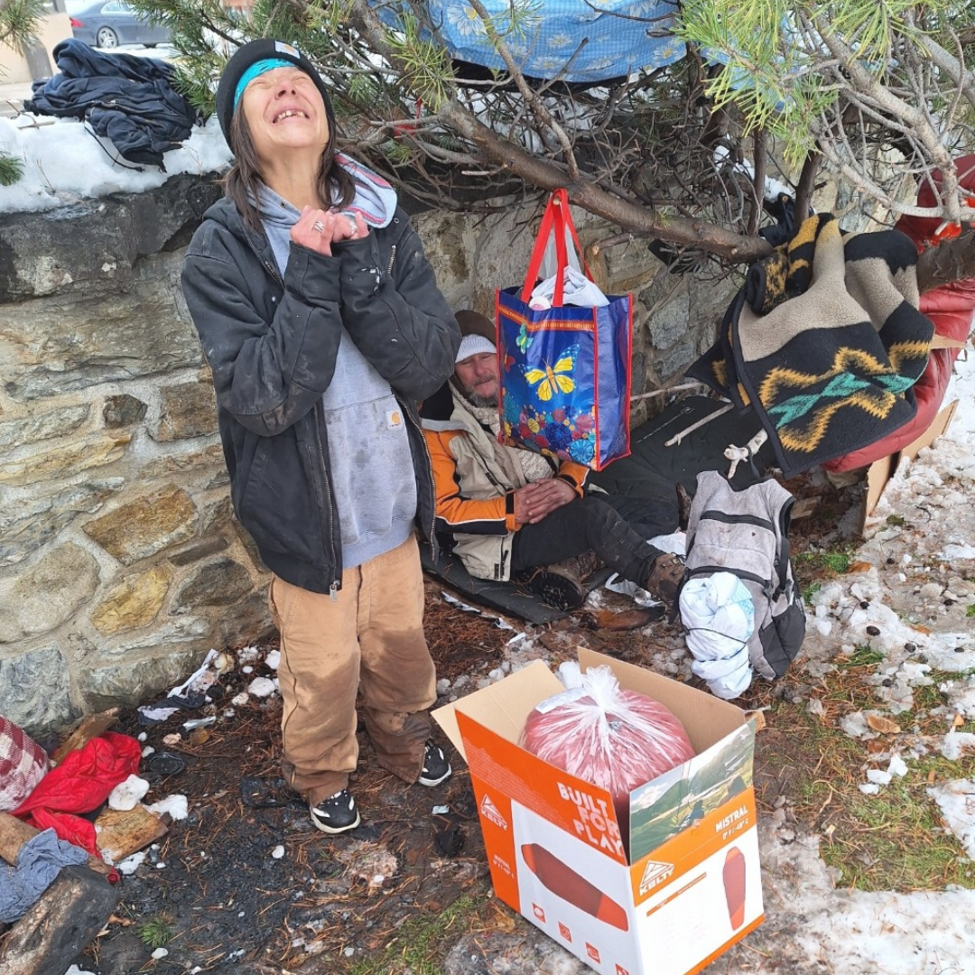
So
May 15, 2024
We won best thrift store of the year!!! And, the third best place to buy books.
Please find the first two policies we will be reviewing below:
- Conflict of Interest Policy and Annual Statement https://docs.google.com/document/d/1gGMzkQ0PsXbRjafjXBeCIgcqndSHiRs_nKiBoBKRBoard Evaluation Policy
- Board Evaluation Policy Draft 8-1-2018
- 990 and 8879 submitted for signature 5/13/2024 Audit going well with all documents submitted
- GSM FP working with chancery office to develop a lease for the Our Place and
Ruth’s Place, the grant from commerce has officially been passed over to Family promise.
- The store is a bit down but the staff are working hard and it's full. Alan and I have both spoken with Mr. Witham and now are waiting for his report.
- Assistance going well with Carrie and services
- Our Place is going well with the staff and curriculum
- Street Outreach- Staff hired to start on the 28th this month.
- Thank you to Dan and Russ for speaking at OLV on GSM. A couple of points from their talk to chat about: advertising on the back backside of the bulletins-we needed to stop due to the budgetary issues. Advertising should be for all parishes and we were only advertising one. Maybe this is a project for the board to all chip in to pay for advertising in each of the bulletins for a year.. The total for all would be $1600 for the year.
- weekly or monthly insert informational blerp on GSM in bulletins. Normally we would be able to get something monthly and now with our new staff in development it should work well. We have onboarded Kat, our development employee who had already created some amazing posts. I’ve asked that she email Dan and Russ to follow up on their ideas.
- Grants submitted: Montana Health Foundation and working on the PATH grant with the County to see if it is viable for street outreach. Kat is looking for other grants or businesses to donate items that normally go into the budget. She is on it!!!!
May 8, 2024
· https://helenair.com/news/local/community-briefs-downtown-cleanup-nurses-honored-bair-family-discussed-daughters-of-nile/article_f6fb87a8-08e8-11ef-b207-bb8d0213c37e.html
· Working at Our Place due to staff being at training for the week
· Submitting permit paperwork for tear down of dressing rooms/moving room dressing rooms.
· Audit is going well with virtual communication and my emails sent 1:1 with Jim or Laura from Pinon
· Final Numbers for the State’s Point in Time Survey Data – Collected in January. In Helena Our Homeless count rose from 164 to 181 from 2023 to 2024.
· We have resubmitted for the Commerce grant with Family Promise for Our Place and Ruth’s Place
· Last of information sent Pinon today-grant going smoothly
· Store running well/staff working well together.
· Paul Witham was in today and will be in tomorrow, spent much time with Alan
Please share the below information, created by our new grant/marketing/Social Medial staff.
A recent survey has revealed a troubling trend in Montana: an increase in the population of those experiencing homelessness. Helena is no exception, with a nearly 10% increase from 2023 to 2024, rising from 164 to 181 individuals.
Good Samaritan Ministries and many local organizations are doing everything they can to support our neighbors during this difficult time, but they need your help.
You can make a difference today by donating:
· Warm Winter Coats
· Shoes (especially mens boots)
· Ready to Eat Items:
· Pop Top Cans
· Jerky
· Granola bars
· Fruits
Donations can be dropped off at Our Place or the Good Samaritan Thrift Store.
Can't bring items in but want to help? Consider making a gift to allow us to provide essential support and resources to those in need. https://www.goodsamhelena.org/give-now/

A great picture of being so happy to feel the weather on her face. Small things make a difference to even those without a home.

May 1, 2024
- Quiet week last week and this as I’ve been ill. The Chancery office came down and volunteered for the dock area and production. Thank you all!!!

- Brad met with Fr. Moriarty regarding the two open positions at St. Mary CC.

- Thank you so Sharon W from Chancery office for jumping to help write a grant for a new dressing room!!! And, thank you for bringing down oodles of volunteers to help get merchandise out.

- John R. I sent you an email to please call Valley bank. If you are open to being a signer or GSM

- Tasks are going smoothly for the collaboration with Family Promise and GSM for Ruth’s Place and Our Place. There will be separate staffing sheets and budgets for both.

- I will again send you the completed document once resubmitted to Commerce. As requested the board will make the final decision once we receive approval from Commerce.

- Someone had asked me about our filing of the 2024 annual report to the office of MSS. This was done in late February. We will post on the Board portal. file:///C:/Users/theresa/Downloads/SKM_C28724050211050.pdf

- We have a possibility of looking at a new grant for outreach if received it would help to create a SOteam.

- A new team has been formed with dock, cashiers, and production. This team has already proved to be a success on many levels. Let me know if you would like additional information. One take away from this group: the team decided to combine two areas into one, adding an hour to a part time employee for both areas. The position for both areas is still under 40. Another position that works part time also covers two departments. It was noted the amount of donations coming in just doesn't warrant full time staff in each area. We have numerous volunteers that have been of tremendous help as well.

April 1, 2024
It appears that donations from parishes have declined over the last few months, discussion?
Pinon Engagement letter
https://mail.google.com/mail/u/0/?tab=rm#search/pinon/FMfcgzGwJJWwbNTfnnNGQjpxmqmFkHZB?compose=CllgCJNqtLDRPkfSVQBmmlWvlxHFLLLFLQvlTtcJKCJjskhTXldszSMXmNMTfRKkTPXjPtgnzdV&projector=1&messagePartId=0.1

April 24, 2024
GREATER HELENA GIVES (GHG)
- https://mail.google.com/mail/u/0/?tab=rm#inbox/FMfcgzGxSlVHnQFGKPqDLpgFTXnCPVSK
- Please help us to prompt GREATER HELENA GIVES (GHG’s) in our community for donations to GSM.Please check out the attached link.
- Audit update: Working with Pinon and Wifli. Wifli has requested to see all documents prior to sending to Pinon. This has caused a slight delay in getting documents out. Audit beginning today 4/23-28th/pending
file:///C:/Users/theresa/Desktop/Good%20Sam-%20KCoe%20SA%20Amendment%204.23.24%20(1).pdf
- Working with Edge Marketing for a new Wednesday’s reports. There was some confusion on their side. We are talking about how to make this happen.
- GSM staff have split days of the dock being open and pick ups in the community. Monday, Wednesdays and Fridays, Sundays dock closed. Dock is open Tuesdays, Thursdays, Saturdays 10:00-5:00. Community pick up days are Wednesdays and Fridays. Dock lunch hour is 1:00-2:00 staff stagger time on the dock. We are looking to only close a ½ hour once we get another staff member.
- Floor plan for Family Promise (2814 N Cook St) and GSM-Our Place and Women’s shelter: Attached to Agenda email.
  - Letter from City, Family Promise facility states: “zoned B2 General Commercial and emergency shelters are allowed” - Ellie Ray, Senior Planner, Community Development Dept.

April 17,2024
- Our store manager is no longer with GSM. Management is taking a new direction with pricing, staffing, intake, floor organizing, hours, consistent pricing and organizing shelves, added Monday’s are now 25% off day for seniors and Vets
- Moving forward with grant resubmit for Commerce. It looks like, and has initially been favored, by the Dept of Commerce, to go with Family Promise on their rebuild/ remodel for OP and Women's Shelter.
- Audit will be the week of the 24th Sam has been preparing documents and sending, as well as. continuing to send documents.
- Sales once again seem to be moving upward. Pickups are Wednesday and Friday, Dock open Tuesdays, Thursdays and Saturdays. Dock closed Sundays, Mondays and Fridays, we look to open on Fridays once we hire a staff for that area.
- Departments doing will with new oversight and ideas.
- Our Place is fully staffed with groups going well.
- Added: We are restarting the advisory committee at Our Place and I was wondering if you would possibly be interested in one hour a month to be part of the group to: (very canned but works):

OP advisory board is a body that provides non-binding strategic advice to the management of a corporation, organization, or foundation. The informal nature of an advisory board gives greater flexibility in structure and management compared to the board of directors

Tentatively the meetings will be on the fourth Thursday of the month at 9:30a.m. during our regular group time, but designated to the advisory committee meeting. First Meeting will be on Apr 25, 20249:30 am.

Fiscal Meeting: 4/23/2024 Good SAmaritan Office
Board Meeting: 4/24/2024

April 10, 2024
- Received contract from ROCKY for Rapid Rehousing and Homeless Prevention 4/24-3/25
- Full update on buildings viewed and discussed: Meeting today to discuss the options for both programs; Our Place and Ruth’s Shelter it looks as though partnering with Family Promise is our best option.
- Quonset Hut-Kitty corner from Food Share. The building is in need of a complete overhaul. Good location however it is zoned for commercial and light manufacturing. The cost is $600,000 or $5900.00 monthly.
- Restore building-Needs extensive work, large, no heating or air conditioning, remodel bathrooms, walls. Not sure the price but at least a million.
- Vacant store next to Van’s-$14000/month. extensive remodeling,the owner is not "most likely won't want to rent to you b/c they just got rid of the homeless hanging around the strip mall.
- Indian Alliance Building N. Last Chance Gulch-Trying to set up a visit. Word is that the building needs extensive remodeling. I am pretty sure once remodeled the rent will be high and only looking for OP we do not have funding for the remodel. In addition, I've put out several calls to IA w/o return calls. With all we have been going though it makes me think they are looking to rent to a different cause/party. Spoke with realtor IA is working toward turning into office space or other business that reflects other businesses downtown area.
- Many Rivers Mental Health Building options-see attached email from Heather. I am waiting for a return email on the Journey Home.
- First Presbyterian Church-First Presbyterian-Met with Janet and a member. There were two options: Upstairs and downstairs for Our Place or Ruth's Place downstairs to talk on one of the wings. Since talking, a message has gotten to me that the neighborhood would not be welcoming to OP on site. Apparently they have gone through issues with homeless wandering? We are waiting to hear what their board says about a women's shelter at this time.
- Modular building company-waiting for specs and cost could be reasonable with the commerce grant funds, however we would need a little over an acre.
- As of 4/8/24! Family Promise and GSM together? Just might work. We are working on a plan to incorporate and collaborate on their new building and existing programming. GSM to bring our programming together; OP and Ruth's Place with FP. Rooms set aside for Ruth's women, and a day room for OP. OP at the facility when FTP clients are at their other location during the hours of 7:30-7:00p.m FP provides more intense family services to those that are homeless. This way we could use Commerce grants to help build. It would also be nice to be able to not have a rent payment, or a small payment for OP and to continue talks with the City for ongoing funding for Ruth's Place as the county does for OP. Unfortunately, not the best location but as the Commissioner Hunhasuen said at the meeting, "some things will have to change or may not be the exact same as they are now". It is very clear homeless programming is not wanted in the downtown area. FP is located/building is zoned for shelter, or as I was told, no zoning. Currently there is shelter of sorts going on in their existing building. Transportation would have to be addressed but we do have a few ideas.

Commerce to be resubmitted by May 1, 2024
Apr 3, 2024
Admin
- Board minutes are on the board portal
- Call into chancery office regarding strategic plan update
- Lowes grant went out for the receptionist remodel
- Investigating a modular building for Ruth’s Place
- Submitted to Edge Marketing to move Wednesday’s report to the Portal
- Thank you Brad for volunteering to take on the board portal with Edge after tax season
- Call put into Chancery for to ask for strategic plan review
- Fire department visit-several items need to be looked at with new regulations
- Have price this weekend
- Our Place option reviews:
  - Kwanzaa Hunt
  - Restore building
  - vacant store next to Van’s
  - Visiting Indian Alliance building no Last Chance Gulch
  - Mental Health Building options, concerns there
  - First Presbyterian Church
- Annual audit to begin in two weeks
  - Brianna sent items to our auditor today
  - Continue to work with Wifli to rap up pre-audit review
- Received $4000, split funds from Helena Area Community Foundation and City of Helena. These fund are also for the reception remodel and used as a match for the Lowe’s grant request
- Have not heard back from Fr. Moriarty, although, correct me if I am in correct, that Brad you were going to visit with Fr. Moriarty?
- Interviewing for Street Outreach and Grant Writer/fundraiser/data manager
  - Both excellent candidates
- Met with Charancy, Sharon Witham and Catholic Life(?)
- Michelle met with Mr. Witham regarding the dock. They will meet again.
- Thank you John for helping to build a budget for Lowes
- HR has continue to attend job fairs which as paid off with interviews
Is there anything else that needs to be added?
Please give me feedback on what you would like to see

Mar 27, 2024
Admin
- Grant received from Helena Community Foundation
https://helenaareacommunityfoundation.org/2024-grantees/
- There was a conversation that the board portal was not adequate after we had had it updated by Edge Marketing. Would anyone like to work with me and Edge for what the board would like to see on the portal?
- Met with Fr. Tim Moriarty, Friday 3/22/2024-St. Mary Catholic Community

March 20,
Admin
- St. Paul’s Methodius Church dinner fundraiser = $730.00
- GSM was not granted the May Butler building. Our community seems to have turned very political and it seems that GSM is smack dab in the middle. I am fearing this will hinder us in the hopes of finding a new building, but we keep chugging along. I have reviewed 5 other buildings. Wednesday, today, I will be visiting First Presbyterian Church on Ewing who is interested in sharing space. All of those properties, we are still dealing with neighborhoods, massive work to be done with a $1,000,000+ price tag. Last visited was the Restore on National, decent location but lots of remodel to be done.
There seems to be mass confusion in the community with non profit programming that has hit the news. Jeff wrote the report after a discussion with community questions: https://mail.google.com/mail/u/0/#search/Jeff/FMfcgzGxSHpnxKPwMBgcFZKVDGLVktFC?projector=1&messagePartId=0.1
https://docs.google.com/file/d/1ycupKr2p8Icr3Et_guyryCVSet_eoVxy/edit?usp=docslist_api&filetype=msword
- This week I have meetings with City Council member/County commissioner, Dan B from the chancery on PR and a planned contact with an investment company for info on the dollar store next to GSM that is closing.
- Link regarding Holiday Inn and United Way
https://www.ktvh.com/news/united-way-looks-to-raise-5-million-in-the-purchase-of-the-helena-inn?fbclid=IwAR2eF0latfbkqf8RJvXLYZrkXRrgeSduuwEsCG4fU86p-TTVd6nKNkyiaKc First information was that the UW was going to purchase for transitional housing and that either Helena Housing or ROCKY was going to manage. Then, it was going to be permanent supportive housing. At this point I am not sure where the plan stands. GSM serves the most in need, those who are homeless, addictions, and other issues. Our folks are not quite ready for housing or unable at their present state.
- Family Promise is building units for family housing behind their current building/property. Initially they were going to use a church they bought for a shelter. They are not able to use the church due to building requirements and zoning. Their office will now move to the church. Again, the grants FP has gotten funds from has GSM listed. I will be checking if FP plans on collaborating with us?
- Store-Numbers seem to be up more. Staff are welcoming the opportunity to meet with a professional organizer for possible direction and support. The dock will stay open until 7:00pm.
- HR-Sam still struggles with the regular hiring issues, however we are now staff with cashiers which will help with the 7:00pm close.
- St. Outreach: Grant submitted-GSM, Helena Health Care Foundation, PureView and FUSE https://acrobat.adobe.com/id/urn:aaid:sc:US:1aa60f0d-a3ca-4af3-b629-140a9b1108b4
- Keeping up on the Street Outreach needs between Tina, Jacqueline, Carrie, and myself. Mark continues to check in periodically to assist.
- Assistance: Kicking to the moon and back Carrie has taken on and done amazing. Serving many people, reorganizing assistance with Tina and me.
There was a conversation that the board portal was not adequate after we had had it updated by Edge Marketing. Would anyone like to work with me and Edge for what the board would like to see on the portal?
Please let me know if this information is what you want in a weekly report?

Mar 13, 2024
I have taken this week as a partial vacation with my kids in Idaho. Partially, I am working online on grants and other tasks.

Administrative

- Draft of RFP submitted to Montana Health Care Foundation:
https://docs.google.com/document/d/1sHRuFoUtQ627o5SEylI7Ul-37BT0jU2JBs4455u5lEQ/edit
- https://youtu.be/ZRzdqY6qGM0?si=SeaYfQM2rZCsnKy9-Why should we care about the homeless.
- Received confirmation from Lowes we are in the top 200 running for the next step in a remodel project to be provided by Lowes. I’ve sent on to John to help with the next steps.
- Thank you Margaret for setting up a time with Paul Witham for a review evaluation of the dock, production and store merchandise, 4/29.
- The next grant to start working on will be to Otto Brenner. I hope to again look towards Our Reach as well
- Lowes Hometown grant for remodeling projects. We have submitted to remodel our front office to provide for better flow and layout for clients and customers. We were notified this week GSM has been moved onto the 200 applicants moving forward. Final application is due April 3rd. John, would you be able to help me with the next step?
- Looking to hire a grant writer/manager
- Friday we should hear about the May Butler Building.
- Much in the paper this week on United Way buying a hotel UW is ramping up for a $4,000,000.00 campaign to purchase.
Family Promise with a new shelter for families only. The church mentioned in the paper they bought will be for Family promise offices and their current building on Cook st, behind Taco Bell will be remodeled for 14 rooms
- Departments are going well; Assistance is charging through the backlog and almost done now moving onward with new clients.
- Audit is set for 4/29 with Pinion and Brianna and I are wrapping up with the pre-audit review
- Store had a great ½ price sale this weekend
- Our Place staff have completed necessary training for Peer Support towards licensures. Groups are going extremely well with community collaborations.

March 5, 2024
Administrative
- 2/28/24 St. Paul’s Friendraiser was well attended. We have not received notification of amount raised
- OLV another well attended fundraiser/friendraiser-approx $3000
- https://docs.google.com/document/d/1aI7e4VS5i5_F1WSSZDJDbtC-Xv6JNgRXS111nBdwBOI/edit cut and past in bar
- Working on a collaborative grant with FUSE, Pureview, GSM for Street Outreach from the streets collaborating services to treatment, mental housing. Due March 15th. More on the grant later.
- Staff training: Two staff have gone to and completed Peer Support training for OP and assistance ministry. Next step is state certification as a Peer Support
- Assistance Ministry is doing with with a team effort (Carrie, Brianna, Sam and Tina)
- Store numbers have been a bit higher and this weekend was a good half price sale
- Two staff were out at training for peer support last week, two have been ill with influenza A, staff out with sick kids with strep
- Visits with Chancery, Rex Seeley (rexseeley@hotmail.com)Ray -Outdoor sports.
- HOpe to hear next week on the Commerce grant. I have visited one possible site, verbally reviewed another and have contacted a realtor.
Short week on information
-----------------------------------------------------------------------------------------------------------------

Wednesday
2/28/28
Admin
- Interesting and sad article for Helena, MT: https://dailymontanan.com/2024/02/06/montana-leads-nation-in-homelessness-increases-in-2023-report-to-congress/
- Volunteer Hours: July through January there were 2,606.33 hours saving us $28, 018.05 in staff salaries (calculated at $10.75/hr)
- Board Matrix: https://docs.google.com/document/d/1Gg-m-19kxQ_xcGU-rKZozDKB8NK5LwTH/edit#heading=h.gjdgxs
- 2/22/24Board Matrix Worksheet.docx
- Board possible tasks:
-Set up a meeting with Mr. Witham, efficiency scientist for Boeing to discuss possible production ideas and/or changes for the dock and on the sales floor
-Monthly bulletin notes
- Our Assistance Ministry-our oldest program provides support for the following; In-Store: Diapers/formula, Clothing, Furniture, Household items and much more. Community Assistance: Financial, Utilities, Rental assistance, Auto Repair, Propane, Medical Prescriptions-with limitations, Gas (only for Medical Appointments) and much more we often take for granted.
- Street Outreach: Is designed to meet the immediate needs of people experiencing homelessness by connecting them with emergency services, housing, or critical services, and providing urgent, non-facility-based care.
- Our Place Drop in Center Our Place is a safe, physical space for men and women to create new beginnings. Our Place is a peer-run support program specializing in behavioral challenges and those recovering from addiction.
- Ruth's Place a Shelter for Women - Currently in process with the City of Helena, Commerce and several nonprofits with collaborative services
- Hunthausen Fund a grant/loan program to help the working struggling to have a home of their own.
_______________________________________________________________________

Wednesday 2/21/13
Admin
- Fiscal meeting 2/27, Board meeting 2/28/24 Agenda: https://docs.google.com/document/d/1wmFd0uiY4XBY6_axdTGGS0LQk88tyGmv/edit
- PR building is going well with Chancery and GSM. Weekly meetings are held during this high focus on GSM
- May Butler RFP/Lease request submitted 2/21/24 - should hear on 2/28/24
https://doc-0g-cc-apps-viewer.googleusercontent.com/viewer/secure/pdf/1hvlmp5223v51v3o57unvl27f8cuk5lr/gc93p5k1jbkdui074r4f2rvo03h5g7cl/1708548450000/gmail/07866535862564631436/ACFrOgD7PCzSd-CowU37MAvCm2E6lvmRaLcf_ykhd-WmBQ9gR-P6hmHzfvnnGsB-Z9UK3RrbqYRluoMPY2uD6vJqrIto5UWmTkf81qd6QqLj_pPOypsyddJN7WHU1XSRVMYwF6UNK5OgkkrgS9Vp?print=true
Previously sent
- Received letter from EFSP/Commerce: Grant: https://drive.google.com/file/d/1yWvYTN_A4xy-DEwNl5VCiA1avllwIDb6/view?usp=sharing
- Minutes from Jan 31, 24 2024:https://docs.google.com/document/d/1fTrC7Iu6napmERJ9GCaIKFG1SzsWDQW-/edit?usp=sharing&ouid=107045263344029833144&rtpof=true&sd=true
- Meeting with Rex Seeley (rexseeley@hotmail.com)2/22 or 2/23/24
- Board assistance needed:
  - Anyone interested on the board of taking on the project for monthly parish bulletins?
  - Plan-Hunthausen Fund- a “wine and Cheese” to report on the grant and to evaluate the Hunthausen Fund for changes.
  - Best of Helena! Michelle adamant “we will regain our title”
- Fundraising:
  - 2/28/2024: St. Paul's United Women in Faith doors open at 5:30 -7:00 presentation on GSM, OP and other activities at GSM. Dinner provided by Richard Ortega
  - Greater HElena Gives May 1-2/2024
  - Sunday this week OLV Chili feed 4:00 pm doors open.
*Link items are also available on board portal

Programs
- Close to cleaning up assistance ministry office, Carrie has moved office and begin with the backlog of missed clients
- advertising and interviewing for: admin assistant: development to include grant writing, marketing, fundraising, donor outreach and database. Also, a fiscal assistant part-time.
- Groups at OP have been full 15-18 each with guest speakers
- Store numbers continue to creep up slowly
Wednesday
2/14/24
- Admin
- 2/8/2024: Superintendent’s office has sent an email to submit for May Butler after questions of eligibility
- Meetings with Chancery office on MB
- Whoooohoooo! Check this link out:https://drive.google.com/file/d/19TlumFiDKCtuGYWvykUjD5roAK6jk17I/view?usp=sharing
https://drive.google.com/file/d/1RESel14a42I4fNQY5rznI7hq8iiF6QQd/view?usp=sharing
- Finally heard from Commerce on the Shelter Grant. Not the full amount, and another submission, but a great response!!!
- May Butler grant to be submitted Friday. THANK YOU JIM, DAN, CHUCK, JOHN AND RICHARD
- 2/14/24 Emergency Solutions Grant (feds pass through) audit. Received commendations for the “good work GSM does in the city of Helena. Thank you to Carrie Brianna Tina!
- ESG- state funds owed to GSM $1,000 for our 2023-2024 grant (July-Feb) year.. Today we received information that we would receive a contract for 2024. Brianna has questioned when the back pay will be sent.
- Fiscal Meeting: 2/21 and Board meeting 2/28.Stephen Mason, Foundation Director from St. Petes to present a $5000.00 check to GSM’s Board. Funds raised for local communities at the annual gala I suggest we stick to this monthly schedule for board meetings since going monthly. .
- An amazing video on Sister Úna Lived a Good Death | End of Life Documentary - Independent Lens
  - https://www.pbs.org/independentlens/documentaries/sister-una-lived-a-good-death/
- Programming
  - Assistance Ministry/internally and externally-Carrie has accepted the position of assistance coordinator. She will slowly transfer from adm assist to assistant coordinator. Admin position will be posted.
  - Our Place Drop in Center-Groups are full, seeing more client to client support, a couple of hard cases worked with Mobile Crisis Team (st petes), and Mental Health with OP.
  - Street Outreach-we are seeing an increased number of women in desperate situations, out in the cold and refusing to stay at our shelter in town.
  - Housing Stability - Nicole is going home to SF. Met with ROCKY today on continuing the grant. More later. Also a passthrough from ROCKY.
  - Hunthausen Fund- a “wine and Cheese” to report on the grant and to evaluate the Hunthausen Fund for changes.
  - Fiscal dept-Busy and has overtime to help clean up.
  - Grants: Due: Lewis and Clark Human Services and Helena Area Community Foundation submitting next week, again submitting May Butler Friday,
  - Successes; Commerce information, submitting May Butler Friday,volunteer luncheon was successful.
The GSM team has pulled together for admin and assistance needs.
  - Challenges: Lots!!
- Follow up from last week's notes:
  - articles to be sent to the parishes monthly. Would a board member be willing to take this task on?

_______________________________________________________________________________________________________________________________________________

Wednesday
2/7/24
- Admin
  - March 27th next board meeting. We will have Stephen Mason, Foundation Director from St. Petes to present a $5000.00 check to GSM’s Board from the Gala benefiting nonprofits in Helena. This will be scheduled first on the agenda.
  - These are the videos from St. Pete’s gala. GSM is highlighted in the community partners. I am sending you information about what is going on in the community of services. Housing is Healthcare - YouTube – Focus on our Housing is Healthcare program that since initiated in November 2022 has transitioned 17 homeless into housing, connected 100 homeless/unstably housed to primary care and, as needed, to mental health and other needed specialties, reduced unnecessary ER visits by 60% and reduced law enforcement interactions by over 80%
St. Peter's Health Community Based Services (youtube.com) – Impact of our Mobile Crisis Response Team, Community Paramedicine, Zero to Five Early Childhood Coalition, Forensic Nursing and Harvest of the Month
St. Peter's Health Community Partners in Helena MT (youtube.com) – Tribute to our many community partners who help us provide our community based services
  - Admin organization chart: https://docs.google.com/document/d/1_TRP7P9rOZtjUv3ZU-LCowaiNyGQq2oz/edit
  - Board meeting minutes for February uploaded to portal
  - New board calendar uploaded to portal
  - Two interviews have been conducted with team members for open positions
  - Contact was made with Fr. Moriarty

- Programming
  - Assistance Ministry/internally and externally
  - Our Place Drop in Center-challenging
  - Street Outreach served Calendar year:
    - 255 unduplicated unsheltered clients in 2023
    - 12 were permanently housed
    - 15 were housed in some sort of transitional form of housing including sober livings
    - 21 were connected to inpatient treatment facilities
    - 250 sleeping bags were issued
    - 75 tents were issued
    - 5115 miles driven
  - Housing Stability - Building the grant/position
  - Hunthausen Fund No new information
  - L&C Human services - grant
  - Admin assist-Taking on clean up for the assistance office and clients
  - Fiscal dept-Taking on clean up for the assistance office and clients
  - Ruth’s Place-On hold for this winter
  - Thrift Store-sales are increasing closing but with the cold front slower again
  - HR-Going well
- Grants
  - Helena Area Community Services: To be submitted for front office remodel, paint and carpeting.
  - Lowes: Submitted for front office remodel, paint and carpeting.
  - Donations: Have asked board members to help with the front office remodel.
- Events/Fundraising
  - https://drive.google.com/file/d/1mMMveU3H6rBGyJt1pezJmUzOpKAI7Qp7/view?usp=sharing
  - Volunteer luncheon
- I Would like monthly articles to be sent to the parishes. Would a board member be willing to take this task on?
________________________________________________________________________________________________________________________________________________

Wednesday Board Report
2/2/2024-update from 1/31/24 meeting
Greetings everyone!
I had good conversations with Brad last night that helped put things in order and perspective for me and I hope to provide what you want from me and for the weekly reports. At a request shared with me the following will be added to the wednesday report as needing updates.

This is the regular outline that will be used for the reports

- Admin-
- In lieu of the recent changes of staffing, staff covering positions for most critical needs. Two positions have been advertised as of yesterday and several staff have taken on portions of the position needs until a hire is put into place
- Cross over training will be started in the very near future, as discussed at the board meeting. The third position will take a back set with division of a few duties for a short time.
- Fr. Moriarty is on vacation this week.

- Programming-overall the programs are running smoothly with the usual staffing issues. We do feel with reorganization of positions and positions that have not been filled we are looking to increase store salaries to be more competitive.
  - Assistance Ministry/internally and externally as discussed and in admin.--internal store donations to those in indeed are in the board reports, support is completed by our receptionist.
  - Our Place Drop in Center Our groups continue to be full, we are waiting for training from the state for peer support.
  - Housing Stability - going slowly but visiting with clients. This grant is a fee for service
  - Hunthausen Fund-many individuals have been assisted with rental deposits in the last month-see board fiscal
  - L&C Human services grant-No LCHS this year
  - Admin assist-
  - Fiscal dept
  - Ruth’s Place-in process of location finding for both programs OP/RP. If not possible we are keeping options open to separate the two programs. Drafting up a RFP for the May Butler building, waiting for the last few questions to be answered. We have created a new team to work on this process to include chancery. The RFP will go to Jim, Bishop, and board prior to sending, if all comes back for us to submit and possibly be accepted.
  - Thrift Store - as stated in meeting slowly sales are increasing.
  - HR-as when possible as there are confidently issues

- Grants-discussed in yesterday's report, received a contract for OP for the next year the state is still behind from October. I am trying to find out when and if they will eventually pay this back

- Events-discussed in yesterday's report

- Successes-stronger collaboration with the chancery staff, creating a PR plan with Chancery, staff jumping to cover openings to keep services going with structure

- Challenges-Sale of OP building, finding a new place for services, Ruth’s Place, waiting to hear on commerce, managing rumors, communication w/i the community, working, handling difficult personal situations, hiring for open positions in admin

- Meetings: Monday mornings PR with Dan and Jim at the chancery, Wednesday our group team meeting RP/OP MB RFP strategizing, Helena Resource Advocates wednesdays, Local advisory Council monthly, Mental Health HPD meeting, FUSE by-weekly, GSM admin meeting wednesdays, monthly staff meeting, occasional city council and county commissioners meetings, meetings with partnering providers as needed.

Wednesday Board Report
1/31/2024
Last month’s time period
Questions from the board meeting 1/31/24:
- 1099’s sent out 1/30/24
- W-2’s sent out by Paylocity e-filed
- Donor letters printed yesterday and going out today. Team of staff and volunteers putting in envelopes. Staff had been working on the top three as part of their jobs
- Volunteer Thank you luncheon 2/13 @ GSM 12:00-1:00-Board welcome
- 32 employees, 13 have openly shared they have had lived experiences
- Working on RFP for May Butler building with a call out to HSD to continue or end writing the RFP. Link to RFP: https://helenaschools.org/wp-content/uploads/2020/05/Photocopier-Pool-RFP.pdf More information to be provided as questions are answered. A draft will go to the bishop and to Brad before submission.
- Stephen Mason,Foundation Director from St. Petes

Staffing:
- Grant writer/development staff leaving and going to Intermountain, more pay and a better fit.
- Street Outreach staff accepted a position at St. Petes
- Assistant Manager no longer at GSM. Details given at the board meeting
- Street Outreach (OP) /MN), RL, past Street Outreach staff will be working with HR to update updating J.D
- Open positions have been posted today and yesterday.

GSM projects:
- Painting has continued with donations at the GSM store. To finish the sidewalls, backwalls, and touch up the conference room and front lobby. We need additional donations to complete. Would the board consider donating to this project or look for possible donors? We need at least $7000.00
Collaborations:
- Restore donations they can’t sell, Ruckers,Home Crafters, Scandinavian
- community team for Ruth’s place
GSM internal information:
- All Staff Meeting held 3rd Fri of every month
- Admin Meeting weekly on Wednesday @ 10:00 unless other meetings, programming take priority.
- Sam-positive working progress on hiring still down 10 positions in the store.
- Salary committee: Sam, Brianna and Theresa will be meeting tomorrow to talk about an increase in store salaries. Outcomes will be reported next week’s updates
- Confirmation students and National Honor Society volunteer opportunities. Sam has made calls.
- Starting 1/26/24 GSM will start donation pick ups Wednesday & Fridays days, the dock is closed. GSM pickups are for large items only. At this point there is no need to advertise until we are fully staffed for truck drivers.
- Store will be opening back to regular hours this spring, 7:00pm.

Newspapers articles/interviews
- 2/1/24: KTVH will interview tomorrow on programs Our Place, Ruth’s Place and what is happening.
- Community PR: Housing sustainability program to be set up
- Articles that are in the paper are largely not from me. It seems to have slowed down. GSM with the Chancery office are building a plan to move forward with the GSM PR plan. I do need to add most of the articles in the paper, I was not aware were going out as I was not called on that interview. What I do know is the building is in process of sale, the landlord has spoken to the chancery office staff, to my knowledge no one has spoken to the potential buyer, at this point it is all hearsay. I will be going to speak with one of the potential buyers to make a win/win situation with the sale and transition with the program when it occurs. It is my understanding through an interview with UW and IR and confirmation from our attorney that we will be able to stay until 3/025, however 0“out sooner than later”.
Grants updates:
- City of Helena admin staff has been notified of our positions with buildings/programs. I have requested to ask the City Commission to reallocate ARPA/City general funds of $136,400 from shelter to a different location, as well as the set aside $1000 , set aside for emergency shelter this winter. City staff is very supportive of GSM and is waiting to hear where we will land.
- Intercept 0 collaboration between pretrial services, FUSE, and GSM to create a grant essentially exactly what our street outreach does. It started as a grass roots program now to get it funded fully.
- A grant has been submitted to Lowe’s in the amount of $50.000 for re-butifying office space. We would like to create a confidential setting in the front office for clients coming in for assistance.
- Commerce grant for the $750.000 was to have notifications out by the end of Jan., we heard today notifications will not go out for another two weeks.
From the board, I would like to know why the decision was made to hold monthly board meetings? Our by-laws state meetings are by-monthly.
Please let me know if you receive and have any questions.
ORG Chart: to be sent
____________________________________________________________________________________________________________________

- Assistance Ministry/internally and externally as discussed and in admin.--internal store donations to those in indeed are in the board reports, support is completed by our receptionist.
  - Our Place Drop in Center Our groups continue to be full, we are waiting for training from the state for peer support.
  - Housing Stability - going slowly but visiting with clients. This grant is a fee for service
  - Hunthausen Fund-many individuals have been assisted with rental deposits in the last month-see board fiscal
  - L&C Human services grant-No LCHS this year
  - Admin assist-
  - Fiscal dept
  - Ruth’s Place-in process of location finding for both programs OP/RP. If not possible we are keeping options open to separate the two programs. Drafting up a RFP for the May Butler building, waiting for the last few questions to be answered. We have created a new team to work on this process to include chancery. The RFP will go to Jim, Bishop, and board prior to sending, if all comes back for us to submit and possibly be accepted.
  - Thrift Store - as stated in meeting slowly sales are increasing.
  - HR-as when possible as there are confidently issues

- Grants-discussed in yesterday's report, received a contract for OP for the next year the state is still behind from October. I am trying to find out when and if they will eventually pay this back

- Events-discussed in yesterday's report

- Successes-stronger collaboration with the chancery staff, creating a PR plan with Chancery, staff jumping to cover openings to keep services going with structure

- Challenges-Sale of OP building, finding a new place for services, Ruth’s Place, waiting to hear on commerce, managing rumors, communication w/i the community, working, handling difficult personal situations, hiring for open positions in admin

- Meetings:
- Admin
- Programming
  - Assistance Ministry/internally and externally
  - Our Place Drop in Center
  - Housing Stability
  - Hunthausen Fund
  - L&C Human services - grant
  - Admin assist
  - Fiscal dept
  - Ruth’s Place
  - Thrift Store
  - HR-as when possible as there are confidently issues
- Grants
- Events
- Successes/Challenges
- Meetings
________________________________________________________________________________________________________________________________________________
I.Admin-
A. Programming-overall
Assistance Ministry/internally and externally
C. Our Place Drop in Center Housing Stability –
D. Hunthausen Fund-
E. L&C Human services grant-
F. Admin assist-
G. Fiscal dept
H. Ruth’s Place-
I. Thrift Store -
J. HR-
- Grants-
- Events/fundraising
- Successes-
- Challenges-
- Meetings:

